Commands taught today:

ls – list all the files and folders in the current directory
cd – change directory to the folder mentioned after the command
&& - execute two commands one after the other
rm – remove file
mkdir – make new folder
rm -r – remove the folder and all the contents inside it
cat – display the contents of a file
mv – move the file
cp – copy the file
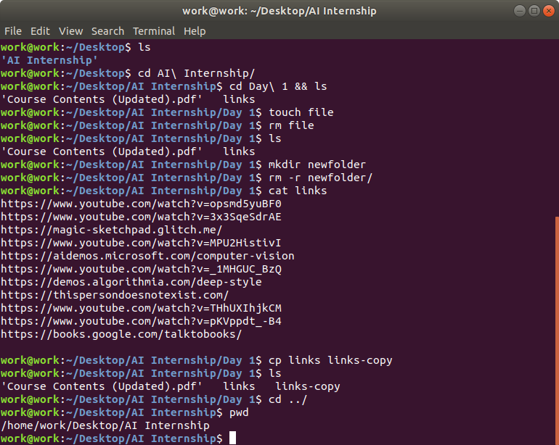
touch – create new empty file

